SVOT Release 1 UAT Data Migration Report
Version 1 | 09/05/2025

Grainger PLC
Single View of Tenancy

Contents
1. Summary 3
2. Tenancies Insert 4
2.1 Migration Strategy 4
2.2 Source Data 4
2.3 Pre-Processing and Deduplication 4
2.4 Setting tenancy start and end dates 5
2.5 Linking Parking & Decant Tenancies to Live Unit Tenancy 5
2.6 Verification Against Salesforce 5
2.7 Insert Tenancies into Salesforce 6
3. Opportunities Update 8
3.1 Migration Strategy 8
3.2 Source Data: 8
3.3 Linking Opportunities to Migrated Tenancies by Unit 8
3.4 Selecting the Most Recent Opportunity 8
3.5 Update Opportunities in Salesforce 9
4. Contracts Update 10
4.1 Migration Strategy 10
4.2 Source Data 10
4.3 Association with an Opportunity 10
4.4 Association with Migrated Tenancy 10
4.5 Account Matching Validation 10
4.6 Update Contracts in Salesforce 11
4.7 Update Failures 11
5. Tenancy Contact Roles Insert 13
5.1 Migration Strategy 13
5.2 Source Data 13
5.3 Linked to Migrated Tenancy 13
5.4 Linked to Contact in UAT 14
5.5 Insert Tenancy Conract Role into Salesforce 14
6. End of Tenancies Update 16
6.1 Migration Strategy 16
6.2 Source Data 16
6.3 Association Check 16
6.4 Status Filtering 16
6.5 Update EOTs in Salesforce 16
6.6 Update Failures 16
7. Opportunity Contact Role Report 19
7.1 Strategy 19
7.2 Source Data 19
7.3 Report 19

- Summary
As part of the Single View of Tenancy (SVOT) project, we need to create new Tenancy records in Salesforce matching all active tenancies in Qube on a one-to-one basis. The details are described in user stories attached to the CJR-393 SVOT - Keep Tenancies Updated & Synced with Qube JIRA epic, specifically the user stories stories below:
- CJR-47 Data Migration - Create Tenancy for all Current Residential Tenancies
- CJR-516 Data Migration - Tenancy Contact Roles
- CJR-174 Data Migration: Link Parking & Decant Tenancies to Live Unit Tenancy

This document describes the process followed for the migration performed with source data from Qube UAT as below:
- Tenant data: https://graingerplc.sharepoint.com/:x:/r/sites/BusinessOptimisation/_layouts/15/Doc.aspx?sourcedoc=%7BFBC0C239-C0A7-41A6-BAE5-B3B0C9FD4A91%7D&file=Grainger%20Tenants-UAT%20140425.xlsx&action=default&mobileredirect=true (“Grainger Tenants-UAT 140425.xlsx”) (Active tenants from Qube UAT as of 14th April 2025)
- Unit lease dates: https://graingerplc.sharepoint.com/:x:/r/sites/BusinessOptimisation/Shared%20Documents/02.0%20Projects%20and%20Workstreams/Single%20View%20of%20Tenancy%20and%20Rent%20Review/Data%20Migration/UAT/Source%20Data%20from%20Grainger/SVOT%20-%20Qube%20Units-Lease%20start%20and%20end%20date%20and%20lease%20terms%20R1.xlsx?d=w8b5797df389340fe89db7fddc37966ea&csf=1&web=1&e=J3Umuq (“SVOT - Qube Units-Lease start and end date and lease terms R1.xlsx”)
The migration was executed against the UAT sandbox and completed on 29th April 2025.
- Tenancies Insert
- Migration Strategy
For every active tenancy in Qube, create a Tenancy record in Salesforce (Contract record with Record Type = “Residential Tenancy”. There should be one and only one tenancy per unit in Salesforce. Historical tenancies that have ended are not migrated from Qube to Salesforce. When migrating into lower test environments (SIT, UAT) some customer and property master data (units, contacts) may not exist in the Salesforce sandbox environment and hence is excluded from the load as per logic described below.
The logic is shown in Figure 2 below.
- Source Data
- Source: https://graingerplc.sharepoint.com/:x:/r/sites/BusinessOptimisation/_layouts/15/Doc.aspx?sourcedoc=%7BFBC0C239-C0A7-41A6-BAE5-B3B0C9FD4A91%7D&file=Grainger%20Tenants-UAT%20140425.xlsx&action=default&mobileredirect=true (“Grainger Tenants-UAT 140425.xlsx”) (Active tenants from Qube UAT as of 14th April 2025)
- Initial Count: 49,768 rows
- Step: Filter out multi-tenant entries by checking the "Con Tran" value.
  - Rows Discarded: 20,695 (Multi-Tenant)
    - https://graingerplc.sharepoint.com/:x:/r/sites/BusinessOptimisation/_layouts/15/Doc.aspx?sourcedoc=%7B95CFF07C-981B-4FCF-AA75-CFD25C635AC0%7D&file=Multi_Tenant.csv&action=default&mobileredirect=true (“Multi_Tenant.csv”)
  - Retained: 29,073 (Single-Tenant or Sharer)
- Pre-Processing and Deduplication
- Get Distinct Tenancies Per Unit:
  - The Qube extract is at Tenant Level. We extracted the distinct Tenancies (by parent_reference) for each unit. The Contract.AccountId is set by taking the ContactId of the first tenant to match one of the below criteria (in order):
    - lead tenant
    - tenant
    - successor reg
    - successor assd per
    - any other value
  - Distinct Tenancies: 19,819
- Qube Missing Salesforce Contact ID?
  - Yes → 41 rows discarded with no Contact Id (“tenant_info” column in Qube extract)
    - https://graingerplc.sharepoint.com/:x:/r/sites/BusinessOptimisation/_layouts/15/Doc.aspx?sourcedoc=%7B576853A6-E624-428E-AEA8-0A841920D5A9%7D&file=No_Contact_ID_In_Qube_Extract.csv&action=default&mobileredirect=true (“No_Contact_ID_In_Qube_Extract.csv”)
  - No → 19,782 rows retained
- Check for Duplicates in Qube (one unit has multiple tenancies):
  - Yes → 109 rows discarded. We kept the tenancy with the most recent start date.
    - parent_reference of tenancies which were discarded because a “newer” (see above) tenancy already exists on the same unit
    - https://graingerplc.sharepoint.com/:x:/r/sites/BusinessOptimisation/_layouts/15/Doc.aspx?sourcedoc=%7BEE0C26CF-B7F2-4A34-89AE-7D455CE117E6%7D&file=Qube_Duplicate.csv&action=default&mobileredirect=true (“Qube_Duplicate.csv”)
  - No → 19,673 rows retained
- Setting tenancy start and end dates
Tenancy start and end date was set using the unit lease start/end date from Qube (see CJR-484 and CJR-522). Unit lease data was provided as per https://graingerplc.sharepoint.com/:x:/r/sites/BusinessOptimisation/_layouts/15/Doc.aspx?sourcedoc=%7B8B5797DF-3893-40FE-89DB-7FDDC37966EA%7D&file=SVOT%20-%20Qube%20Units-Lease%20start%20and%20end%20date%20and%20lease%20terms%20R1.xlsx&action=default&mobileredirect=true (“SVOT - Qube Units-Lease start and end date and lease terms R1.xlsx”)

- Linking Parking & Decant Tenancies to Live Unit Tenancy
The data migration logic attempts to link parking and decant tenancies to the live unit tenancy based on requirements in CJR-174, allowing the visualisation shown in Figure 1 below. This relationship does not exist in Qube and is inferred on a “best effort” basis during the data migration. Going forward, new parking/decant tenancies will be initiated in Salesforce from the tenancy record, hence will be linked automatically.
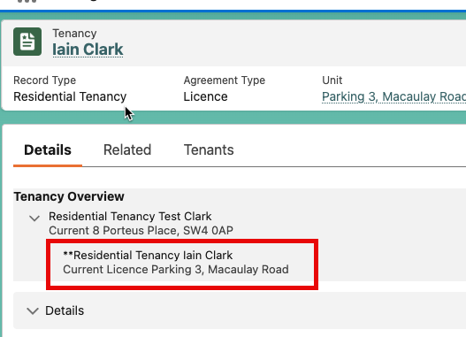
Figure 1 - Parking/Decant Tenancy linked to Live Unit Tenancy
This is done by linking active tenancies that have the same tenant (i.e. where Contract.AccountId matches between a live unit tenancy and one or more parking/decant tenancies). For Tenants that have multiple live unit tenancies (e.g. for company lets), this logic is not applied to parking and decant tenancies.
- Verification Against Salesforce
- Check if Unit Exists in Salesforce:
  - No → 6 rows discarded (Units not in Salesforce UAT sandbox)
    - https://graingerplc.sharepoint.com/:x:/r/sites/BusinessOptimisation/_layouts/15/Doc.aspx?sourcedoc=%7BE508090A-CC09-4154-9E4B-173F96D128BF%7D&file=Tenancy_Unit_Not_In_Salesforce.csv&action=default&mobileredirect=true (“Tenancy_Unit_Not_In_Salesforce.csv”)
  - Yes → 19,666 rows retained
- Check if Contact Exists in Salesforce:
  - No → 66 rows discarded (Contacts not in Salesforce UAT sandbox)
    - https://graingerplc.sharepoint.com/:x:/r/sites/BusinessOptimisation/_layouts/15/Doc.aspx?sourcedoc=%7B7154B457-2F8A-475B-A6F0-18ABEF6AAD05%7D&file=Tenancy_Contact_Not_In_Salesforce.csv&action=default&mobileredirect=true (“Tenancy_Contact_Not_In_Salesforce.csv”)
  - Yes → 19,600 rows retained
- Insert Tenancies into Salesforce
- Insert Records into Salesforce:
  - Success: 19,600
  - Failures: 0
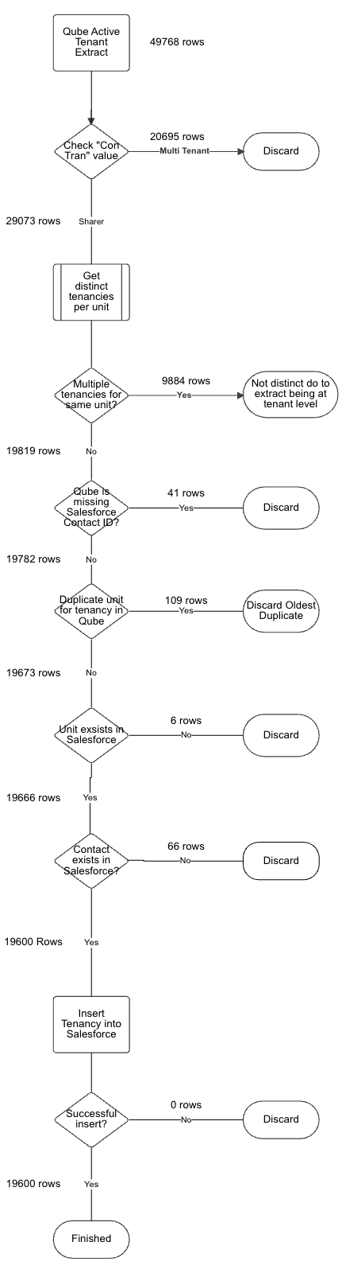
Figure 2 - Tenancy Migration Logic
- Opportunities Update
- Migration Strategy
For every active tenancy record created in Salesforce as per 2 above, identify the opportunities that are related to this tenancy. These opportunities may be the first “New” opportunity corresponding to the creation of the tenancy or one or more “Renewal” opportunities corresponding to renewals or change of sharer transactions that have occurred during the tenancy’s life cycle.
For the opportunities identified above, update the Opportunity.Tenancy__c field so that the opportunities reflect as child records beneath the Residential Tenancy.
If any opportunities identified above have a blank value in the Opportunity.PMS_Reference__c field, this field is not updated. Instead a file is provided to Grainger for review, after which a manual update can be made (in bulk) to update the PMS Reference as required (see CJR-479 and CJR-520).
Only opportunities relating to current active tenancies are updated. Historical opportunities relating to ended tenancies are not included in any updates.
The logic is shown in Figure 3 below.
- Source Data:
- Opportunities in UAT:
  - Total records: 59,181
- Linking Opportunities to Migrated Tenancies by Unit
- Condition: Is there a migrated tenancy for the same unit as Opportunity.Primary_Offer_Live_Unit__c or Opportunity.Primary_Offer__r.Unit__c?
  - No → 8,507 rows discarded
    - https://graingerplc.sharepoint.com/:x:/r/sites/BusinessOptimisation/_layouts/15/Doc.aspx?sourcedoc=%7B2AE8D6EF-7C39-4699-9708-C0955FED2785%7D&file=Opp_Not_Linked_To_Migrated_Tenancy.csv&action=default&mobileredirect=true (“Opp_Not_Linked_To_Migrated_Tenancy.csv”)
  - Yes → 51,311 rows retained
- Selecting the Most Recent Opportunity
- Filter for the most recent (by Created Date) "New" and "Renewal" opportunities per tenancy.
- After applying this logic:
  - Remaining rows: 34,157
  - These include:
    - 4,846 linked by PMS Reference (i.e. Opportunity.PMS_Reference__c matches PMS Reference of migrated tenancy)
    - 29,320 linked by Unit (i.e. Opportunity.Primary_Offer_Live_Unit__c or Opportunity.Primary_Offer__r.Unit__c matches unit of migrated tenancy). Opportunities matched by this criteria are likely to be older opportunities that were closed before the Salesforce->Qube integration was in place, hence do not have a PMS Reference number updated on the Opportunity via the GREP integration)
- Outdated Opportunities (not the most recent "New" and "Renewal" opportunities for a given tenancy):
  - 17,145 rows discarded as outdated opportunities
    - https://graingerplc.sharepoint.com/:x:/r/sites/BusinessOptimisation/_layouts/15/Doc.aspx?sourcedoc=%7BD8EE0480-CCAD-4131-8CCE-EE88B867E956%7D&file=Not_Most_Recent_Opp_By_PMS_Unit.csv&action=default&mobileredirect=true (“Not_Most_Recent_Opp_By_PMS_Unit.csv”)
- Update Opportunities in Salesforce
- Update Records in Salesforce:
  - Success: All 34,157 rows successfully updated
  - Failures: 0 failed updates
  - 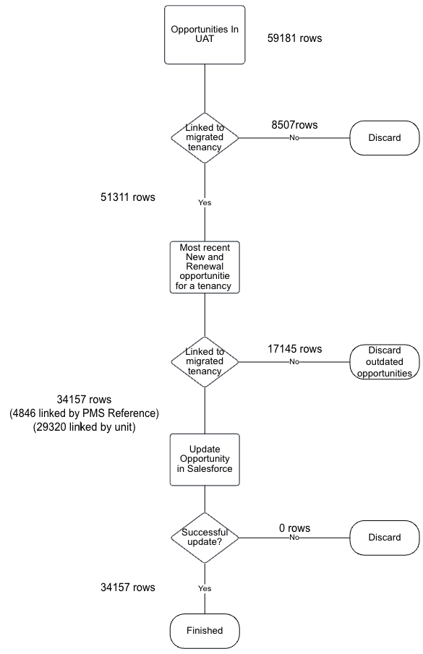
Figure 3 - Opportunity Update Logic
- Contracts Update
- Migration Strategy
For every active tenancy record created in Salesforce as per 2 above, identify the contracts (Contract records with Record Type = “Residential Contract”) that are related to this tenancy. These contracts may be the first “New” contract corresponding to the creation of the tenancy or one or more “Renewal” contracts corresponding to renewals or change of sharer transactions that have occurred during the tenancy’s life cycle.
For the contracts identified above, update the Contract.Tenancy__c field so that the contracts reflect as child records beneath the Residential Tenancy.
Only contracts relating to current active tenancies are updated. Historical contracts relating to ended tenancies are not included in any updates.
The logic is shown in Figure 4 below.
- Source Data
- Contracts in UAT where Record Type = “Residential Contract” and Opportunity is not null:
  - Total contracts: 31,911
- Association with an Opportunity
- Check: Is the contract associated with an opportunity in UAT?
  - No → 26 rows discarded
    - https://graingerplc.sharepoint.com/:x:/r/sites/BusinessOptimisation/_layouts/15/Doc.aspx?sourcedoc=%7BA0FE57D0-10FA-4523-BA9D-B4CDEDC0462E%7D&file=Contract%20Not_Linked_To_Opp_In_Salesforce.csv&action=default&mobileredirect=true (“Contract Not_Linked_To_Opp_In_Salesforce.csv”)
  - Yes → 31,885 rows retained
- Association with Migrated Tenancy
- Check: Is the contract linked to an Opportunity that is now linked with a migrated tenancy via 3 above?
  - No → 3,076 rows discarded
    - https://graingerplc.sharepoint.com/:x:/r/sites/BusinessOptimisation/_layouts/15/Doc.aspx?sourcedoc=%7B68930379-D978-4E53-85CE-B60E45B7EECB%7D&file=Contract_Not_Linked_To_Migrated_Tenancy.csv&action=default&mobileredirect=true (“Contract_Not_Linked_To_Migrated_Tenancy.csv”)
  - Yes → 17,246 rows retained
- Account Matching Validation
*Documented but not enforced during migration due to frequent ambiguity in identifying the lead tenant in the Qube extract, which often causes mismatches.
- Check: Does the account on the updated contract match the account on the migrated tenancy?
  - No → 3,163 rows fail this check but were not discarded in this migration
    - https://graingerplc.sharepoint.com/:x:/r/sites/BusinessOptimisation/_layouts/15/Doc.aspx?sourcedoc=%7BFAB9BB44-D96D-4CC8-B3ED-3A8D40A69CCF%7D&file=AccountMissmatch.csv&action=default&mobileredirect=true (“AccountMissmatch.csv”)
  - Yes → 11,476 rows pass
  - Retained → 17,246
- Update Contracts in Salesforce
- Attempted updates: 17,246 contracts
  - Success: 17,194
  - Failures: 52
    - https://graingerplc.sharepoint.com/:x:/r/sites/BusinessOptimisation/_layouts/15/Doc.aspx?sourcedoc=%7BDCF2B6BB-9089-4D75-8F70-651E7E89C7FD%7D&file=Salesforce_Kick_Outs.xlsx&action=default&mobileredirect=true (“Salesforce_Kick_Outs.xlsx”)

- Update Failures
- Failure Reasons:
  - 4 rows failed due to validation exception (bad data in Agreement_Type in UAT)
  - 48 rows failed due to inability to reset contract status (caused by conflicts with previously migrated Qube production data)

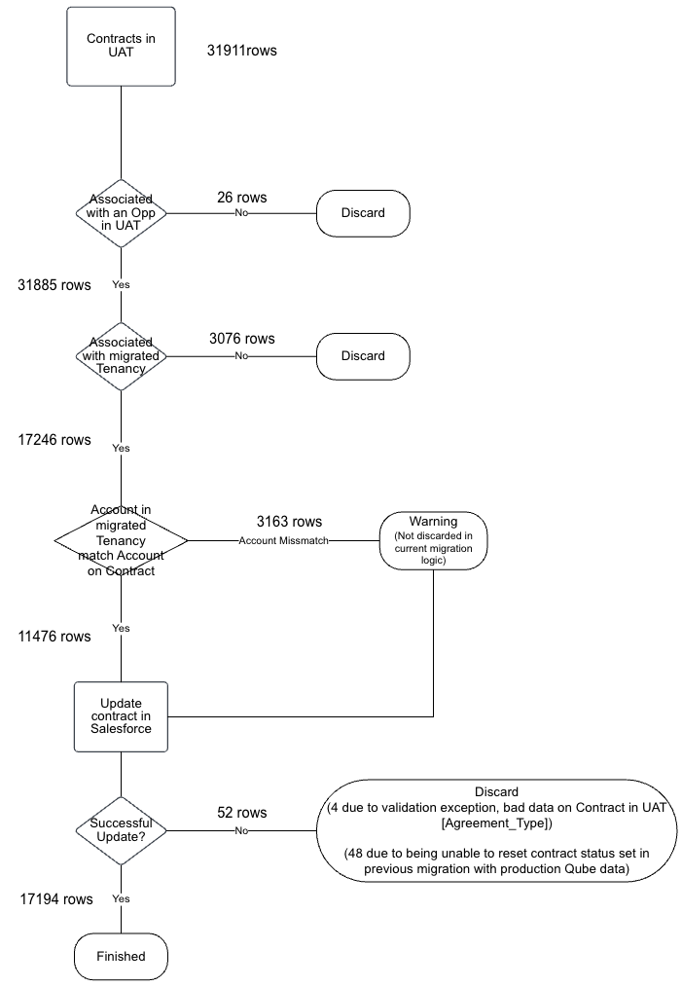
Figure 4 - Contract Update Logic
- Tenancy Contact Roles Insert
- Migration Strategy
Use the list of active tenants from Qube to identify all Contacts who are linked to active tenancies. Insert new Tenancy_Contact_Role__c records for each of these Contacts, including the “Role” and “Start Date” and “End Date”.
When migrating into lower test environments (SIT, UAT) some customer master data (contacts) may not exist in the Salesforce sandbox environment and hence is excluded from the load as per logic described below.
The logic is shown in Figure 5 – Tenancy Contact Role Insert Logic below.
- Source Data
- Source:
  - https://graingerplc.sharepoint.com/:x:/r/sites/BusinessOptimisation/_layouts/15/Doc.aspx?sourcedoc=%7BFBC0C239-C0A7-41A6-BAE5-B3B0C9FD4A91%7D&file=Grainger%20Tenants-UAT%20140425.xlsx&wdLOR=c1E012240-7F58-1043-946D-72D3920892CF&action=default&mobileredirect=true
(“Grainger Tenants-UAT 140425.xlsx”)
(Active tenants from Qube UAT as of 14th April 2025)
- Initial Count: 49,768 rows
- Unique Contact Roles: 29,074 rows

- Role Mapping Logic:
Roles from Qube were mapped to their corresponding roles in Salesforce as follows. If a Qube role did not have a direct match in Salesforce, it was assigned the role of 'Relevant Person'.
Qube Tenant Role | Mapped Salesforce Contact Role
Lead Tenant | Lead Tenant
Tenant | Tenant
Additional occupier | Permitted Occupier
Guarantor | Guarantor
Successor Reg | Successor (Regulated)
Successor Assd Per | Successor (Assured Periodic)
POA | Power of Attorney
Previous | Relevant Person
Alternative contact | Relevant Person
Else | Relevant Person
- Linked to Migrated Tenancy
- Check: Is the Tenancy Contact Role Liked to a migrated tenancy in UAT?
  - No → 254 rows discarded
    - https://graingerplc.sharepoint.com/:x:/r/sites/BusinessOptimisation/_layouts/15/Doc.aspx?sourcedoc=%7B36F49589-9DCC-427B-823F-8922FA517A11%7D&file=Not_Linked_To_Migrated_Tenancy.csv&wdLOR=c916623BC-043B-BF43-BF73-32A84AFF236D&action=default&mobileredirect=true
(“Not_Linked_To_Migrated_Tenancy.csv”)
  - Yes → 28,819 retained
- Linked to Contact in UAT
- Check: Is the Tenancy Contact Role Liked to a contact in UAT?
  - No → 23 rows discarded
    - https://graingerplc.sharepoint.com/:x:/r/sites/BusinessOptimisation/_layouts/15/Doc.aspx?sourcedoc=%7B756BFAAF-DBAB-4FEE-9261-78E73D81F5B4%7D&file=Contact_Not_In_UAT.csv&action=default&mobileredirect=true
(“Contact_Not_In_UAT.csv”)

  - Yes → 28,792 retained
- Insert Tenancy Conract Role into Salesforce
- Attempted updates: 28,792 tenancy contact roles
  - Success: 28,792
  - Failures: 0

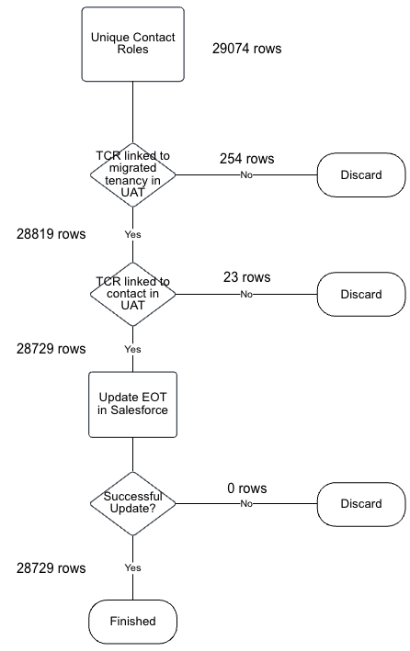
Figure 5 – Tenancy Contact Role Insert Logic

- End of Tenancies Update
- Migration Strategy
Identify any in progress End of Tenancy (EoT) records that are currently linked to a contract that is part of an active tenancy. For these records, update them to link to the Tenancy record (instead of the Contract) so that they can be completed following the EoT process which now (i.e. post SVOT Release 1) requires the EoT to be linked to the Tenancy, not the contract.
The logic is shown in Error! Reference source not found. below.
- Source Data
- EOTs in UAT:
  - Total rows: 1,586
- Association Check
- Check: Is the EOT linked to both a contract that is linked to a migrated tenancy?
  - No → 1,481 rows discarded
    - https://graingerplc.sharepoint.com/:x:/r/sites/BusinessOptimisation/_layouts/15/Doc.aspx?sourcedoc=%7BC6C3839D-8104-435B-9AB9-4CFE0FB9B857%7D&file=EOT_Linked_To_Tenancy.csv&wdLOR=cA3D8C8FC-0D00-9A4D-803B-CAB14AA8F3FB&action=default&mobileredirect=true
(“EOT_Linked_To_Tenancy.csv”)
  - Yes → 87 rows retained
- Status Filtering
- Check: Is the EOT in an Active, Pending Cancel/Close status?
  - No → 78 rows discarded
    - https://graingerplc.sharepoint.com/:x:/r/sites/BusinessOptimisation/_layouts/15/Doc.aspx?sourcedoc=%7B4CD2B849-467A-46B2-87A8-CC9E77D9A517%7D&file=EOT_In_Valid_Status.csv&wdLOR=cC39D4294-C6C0-DE4E-8592-FC64F06653D2&action=default&mobileredirect=true
(“EOT_In_Valid_Status.csv”)
  - Yes → 9 rows retained
- Update EOTs in Salesforce
- Attempted Updates: 634
  - Success: 7 rows
  - Failures: 2 rows
    - https://graingerplc.sharepoint.com/:x:/r/sites/BusinessOptimisation/_layouts/15/Doc.aspx?sourcedoc=%7BE3673858-2D53-4A8A-B5C3-FE41A893E1BE%7D&file=Salesforce_Kick_Outs.xlsx&wdLOR=cB7D8E052-2D45-8645-A8CE-18AC8BC7E372&action=default&mobileredirect=true
(“Salesforce_Kick_Outs.xlsx”)
- Update Failures
- Failure Reasons:
  - Validation Exception: Mismatch in Actual_vacate_Date__c between EOT and Tenancy
  - These 2 rows were discarded

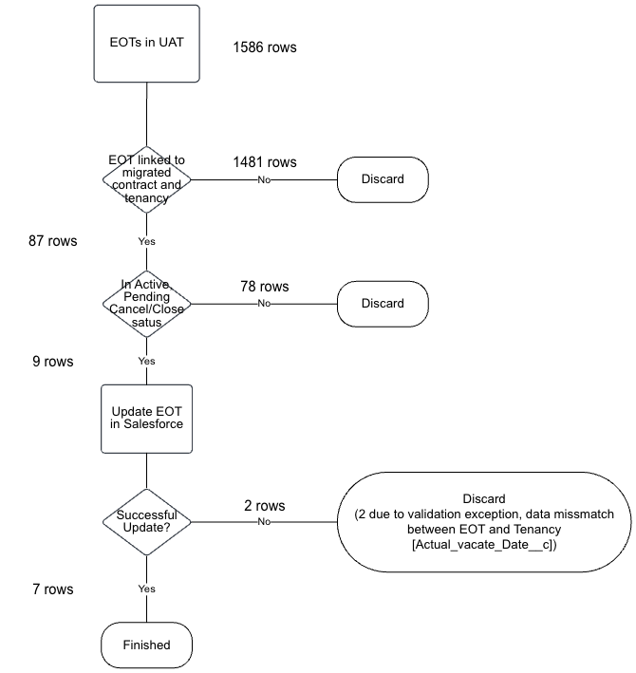
Figure 6 - EoT Update Logic
- Opportunity Contact Role Report
- Strategy
During the data migration testing, it became apparent that the Tenant data in Qube may not accurately reflect the latest tenants in Salesforce due to changes that have been made for renewals and change of sharers. We created a report to show Opportunity Contact Roles from Salesforce linked to active tenancies, with the intention that Grainger are able to use this report to compare to Qube and update Qube as required.
- Source Data
- OpportunityContactRole records:
  - Find all OpportunityContactRole records linked to the “most recent” opportunity for each Tenancy (see 3.4 above for details on how “most recent” opportunity is selected). i.e. the most recent opportunity will be the most recently created opportunity within the tenancy, either a “new”, “renewal” or “change of sharer”. The OpportunityContactRole records linked to this opportunity should provide an accurate reflection of the current tenants.
- Report
The report has been generated at
https://graingerplc.sharepoint.com/:x:/r/sites/BusinessOptimisation/_layouts/15/Doc.aspx?sourcedoc=%7BDA6691A7-1561-4CD3-A1EB-68E74320A0CC%7D&file=OCR_Report.csv&action=default&mobileredirect=true

Number of rows: 59123
As shown in Figure 7 below, the report includes a “derived primary key”, created by concatenating the Salesforce Contact Id and Qube PMS Reference. This derived primary key can be used to compare Salesforce Opportunity Contact Roles to the Qube Tenants for each active tenancy.

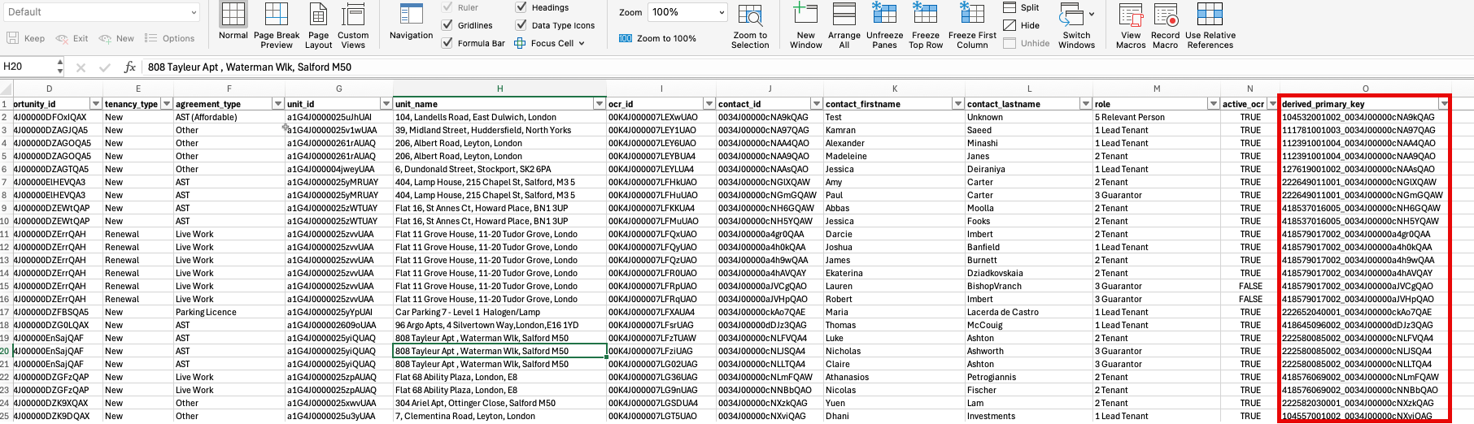
Figure 7 - Opportunity Contact Role Report

